## Describe NGO campaign Goals: Awareness, donations, volunteers, subscriptions, events, etc

### Campaign Goals

* Awareness

### Landing Page Research

#### Audience

* Parents of children aged 3-8
* Kindergarten and primary school teachers
* School administrators
* Community members interested in storytelling and child development

Explain your initial Google Ads strategy

1. Campaign themes, ad groups, sample of keywords/negative keywords, sample ad copy, bidding strategies, targeted audience, etc.
2. How did you choose your strategy at first and why do you expect them to reach the client’s goals?
3. Show your key performance metrics: impressions, clicks, CPC, CTR, spend

Version 1

Kindergarten/Primary school faculty ad group

|  |  |  |
| --- | --- | --- |
| Keyword | Match type | Status |
| how to prevent school bullying | Broad match | Eligible |
| parenting tips | Broad match | Eligible |
| bullying prevention | Broad match | Eligible |
| child development | Broad match | Eligible |
| tutoring centers near me | Broad match | Eligible |
| emotional management course for kids | Broad match | Not eligible |
| early childhood development | Broad match | Eligible |
| kids activities | Broad match | Eligible |
| character building activities | Broad match | Eligible |
| children financial literacy workshop | Broad match | Not eligible |
| child education | Broad match | Eligible |
| teaching kids about money | Broad match | Eligible |
| values education program | Broad match | Eligible |
| emotional intelligence training for children | Broad match | Eligible |
| parent-child reading classes | Broad match | Not eligible |
| character education | Broad match | Eligible |
| emotional learning | Broad match | Eligible |
| positive parenting skills | Broad match | Eligible |
| early learning center | Broad match | Eligible |
| after school | Broad match | Eligible |
| learning center | Broad match | Eligible |
| school bullying prevention program | Broad match | Eligible |
| kids finance | Broad match | Eligible |

Problems with version 1

* Not fully aligned with landing page, leading to a lower quality score
* Lack of exact matches and phrase matches, causing the stages further down in the funnel to be weaker, explaining the weaker conversion rate
* Low impressions indicate weak broad matches, increasing the volume of keywords can help

Keyword research

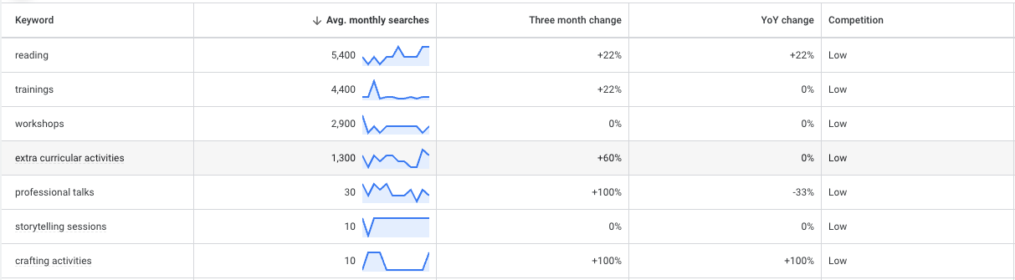

Initial A/B test

Version 2

Share your A/B testing plan and any findings.

What other changes did you make to your original strategy? What are the rationale of the changes?

1. For example, did you add or drop the keyword? Any modifications to the ad copies? Or bidding strategy?

Future recommendations

1. What are your key takeaways or highlights from this project?
2. What recommendations would you offer to the NGO for their future campaigns?

Your report will also be shared to them for future use.

Revision

|  |  |  |
| --- | --- | --- |
| Keyword | Match type | Status |
| School partnership | Broad match | Eligible |
| School collaboration |  |  |
| Local schools | Broad match | Eligible |
| Extended activities | Broad match | Eligible |
| child development | Broad match | Eligible |
| Storytelling platform | Broad match | Eligible |
| Extra curricular activity | Broad match | Not eligible |
| early childhood development | Broad match | Eligible |
| Hans andersen club |  |  |
| Local school partnership |  |  |
| NGO partnership |  |  |
| Hong Kong NGO |  |  |
| Educational NGO |  |  |
| charity |  |  |
| Ngo collaboration |  |  |
| School and NGO collaboration |  |  |
| kids activities | Broad match | Eligible |
| character building activities | Broad match | Eligible |
| children financial literacy workshop | Broad match | Not eligible |
| child education | Broad match | Eligible |
| teaching kids about money | Broad match | Eligible |
| values education program | Broad match | Eligible |
| emotional intelligence training for children | Broad match | Eligible |
| parent-child reading classes | Broad match | Not eligible |
| character education | Broad match | Eligible |
| emotional learning | Broad match | Eligible |
| positive parenting skills | Broad match | Eligible |
| early learning center | Broad match | Eligible |
| after school | Broad match | Eligible |
| learning center | Broad match | Eligible |
| school bullying prevention program | Broad match | Eligible |
| kids finance | Broad match | Eligible |

### **1. Broad Matches (Top of the Funnel)**

These keywords are designed to attract a wide audience who might be generally interested in children's activities, storytelling, and educational programs.

* Children's storytelling
* Children's book clubs
* Local School partnership
* NGO Partnership
* Hong Kong charity

### **2. Phrase Matches (Middle of the Funnel)**

These keywords are more specific and target users who are actively searching for storytelling and educational programs for children.

* "children's storytelling workshops"
* "kids' reading programs Hong Kong"
* "family storytelling events"
* "educational activities for kids"
* "parent-child workshops"
* "storytelling for children"
* "children's book reading sessions"
* "early childhood storytelling"

### **3. Exact Matches (Bottom of the Funnel)**

These keywords are highly specific and target users who are ready to engage with Storyland at Hans Andersen Club.

* [Storyland Hans Andersen Club]
* [children's storytelling Hong Kong]
* [kids' reading programs Storyland]
* [family workshops Storyland]
* [parent-child activities Storyland]
* [Storyland educational programs]
* [children's book club Storyland]
* [early childhood education Storyland]

### **1. Broad Matches (Top of the Funnel)**

Headline 1: "Inspire Your Child with Stories" Headline 2: "Join Our Children's Storytelling Events" Description: "Discover the magic of storytelling at Storyland. Fun and educational activities for kids and families. Join us today!"

Headline 1: "Educational Fun for Kids" Headline 2: "Storytelling & Reading Programs" Description: "Engage your child with our interactive storytelling sessions. Perfect for young minds. Sign up now!"

### **2. Phrase Matches (Middle of the Funnel)**

Headline 1: "Children's Storytelling Workshops" Headline 2: "Interactive Reading Programs" Description: "Enhance your child's creativity and communication skills with our storytelling workshops. Register today!"

Headline 1: "Family Storytelling Events" Headline 2: "Parent-Child Workshops" Description: "Strengthen family bonds through our engaging storytelling events. Suitable for all ages. Learn more!"

### **3. Exact Matches (Bottom of the Funnel)**

Headline 1: "Storyland at Hans Andersen Club" Headline 2: "Join Our Storytelling Programs" Description: "Experience the best in children's storytelling at Storyland. Limited spots available. Enroll now!"

Headline 1: "Kids' Reading Programs at Storyland" Headline 2: "Educational Activities for Children" Description: "Join our exclusive reading programs designed for young learners. Visit Storyland today!"